Liverpool Road Workhouse Records
Liverpool_Rd_1866_Whole_Family_Admissions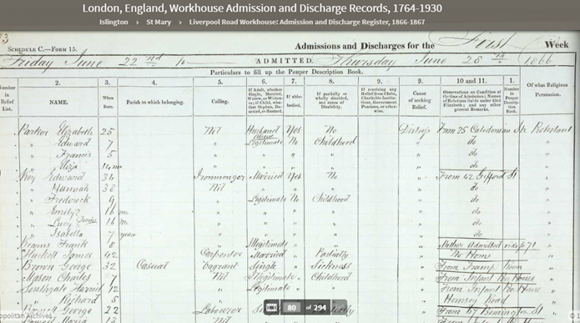
Liverpool_Rd_Discharges_1866_V2
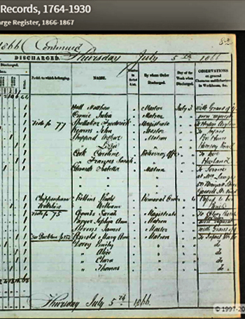

Liverpool_Rd_Admissions_Mary_Jones_Cloudesley_Street_1866
